Once login to linux execute sudo su – , this is like super user access

Cat .bashrc: When system start it will run automatically

**How to use Alias?**

**Assign any command or statement to a word or letter**

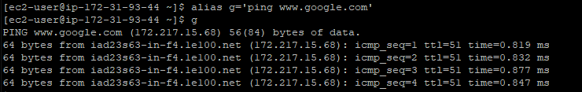

Note: Once you exit(logout)from the user alias will be removed, to overcome this problem , go to .bashrc file and make an entry inside.

**Open .bashrc file**

nano .bashrc

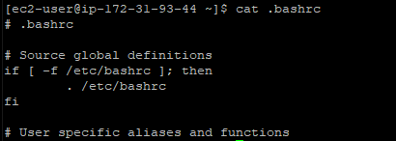

Make an entry as shown below

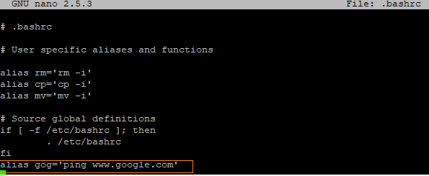

Execute below command



After exit also alias will still work

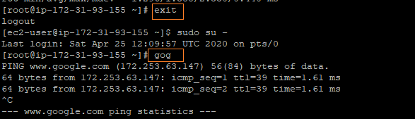

**About permissions**: for any shell script we need to provide chmod 700 for execution

Read-4

Write-2

Execute-1



#!/bin/bash

I=0

while [ $I -lt 101 ]; do

    if [ $(expr $I % 2) -ne 0 ]; then

        echo "$I is an ODD number"

    fi

    I=$(($I + 1))

done

Output

